**Project Design Phase-I**

**Solution Architecture**

|  |  |
| --- | --- |
| **Date:** | 3 November,2023 |
| **Team Id:** | NM2023TMID03725 |
| **Project Name:** | Create a Google My Business profile |

**Solution Architecture:**

Solution architecture is a complex process – with many sub-processes – that bridges the gap between business problems and technology solutions. Its goals are to:

* Find the best tech solution to solve existing business problems.
* Describe the structure, characteristics, behaviour, and other aspects of the software to project stakeholders.
* Define features, development phases, and solution requirements.
* Provide specifications according to which the solution is defined, managed, and delivered.

**Product Design and Formulation:**

* Define the soap product's specifications, including its ingredients, scent, color, and intended use (e.g., hand soap, body soap, specialty soap).
* Work with chemists and product designers to create the soap's formulation.

**Manufacturing and Production:**

* Choose the manufacturing method (e.g., cold process, hot process, melt and pour) and establish production facilities.
* Design the production line, specifying the equipment and processes involved.
* Ensure adherence to quality control standards and regulations.

**Supply Chain Management:**

* Source raw materials, such as oils, fragrances, and additives, from suppliers.
* Establish inventory management processes to track and control raw materials and finished products.
* Develop relationships with suppliers to ensure a stable supply chain.

**Quality Assurance and Testing:**

* Implement quality control procedures to test raw materials and finished products for consistency and safety.
* Conduct stability and safety testing to ensure the product meets regulatory requirements.

**Packaging and Labelling:**

* Design the soap's packaging, considering sustainability, branding, and product protection.
* Create labels that comply with legal and regulatory requirements and communicate product information clearly.

**Distribution and Logistics:**

* Determine the distribution channels, whether through retail, e-commerce, or both.
* Establish warehousing and logistics processes for storing and shipping products efficiently.

**Sales and Marketing:**

* Develop a marketing strategy to promote the soap product.
* Consider branding, pricing, advertising, and sales channels.
* Monitor customer feedback and adjust marketing strategies accordingly.

**Regulatory Compliance:**

* Ensure compliance with regulatory standards for soap products, which may vary by region or country.
* Maintain documentation to demonstrate compliance, including safety data sheets, ingredient lists, and manufacturing records.

**Environmental Considerations:**

* Implement environmentally friendly practices, such as sustainable sourcing, minimal packaging waste, and responsible disposal of waste.

**Customer Support and Feedback:**

* Establish customer support processes to handle inquiries, concerns, and feedback.
* Use customer feedback to improve the product and address any issues or concerns.

**Continuous Improvement:**

* Regularly review and improve the product and its processes based on customer feedback, market trends, and internal assessments.

**Technology Infrastructure:**

* Implement and maintain technology systems for order management, inventory tracking, and sales data analysis.
* Consider e-commerce platforms, ERP (Enterprise Resource Planning) systems, and CRM (Customer Relationship Management) tools.

**Processes involved in soap production:**

**Raw Material Storage:**

* This is where raw materials such as oils, fats, and chemicals are stored before they are used in the soap-making process.

**Raw Material Preparation:**

* Raw materials are measured and mixed to create the soap base. This process may involve heating and blending to achieve the desired consistency.

**Saponification**:

* The soap base is mixed with sodium hydroxide (lye) in a reaction called saponification. This chemical process transforms the raw materials into soap.

**Additives and Fragrance:**

* Additional ingredients such as fragrances, colorants, and other additives are mixed into the soap base to enhance its properties and appeal.

**Moulding and Shaping:**

* The liquid soap is poured into Molds, where it cools and solidifies into the desired soap bar or shape.

**Cutting and Trimming:**

* Once the soap has solidified, it is cut into individual bars or shapes. Any excess material is trimmed.

**Curing**:

* The freshly cut soap bars are left to cure for a specified period to allow excess moisture to evaporate and for the soap to harden.

**Quality** **Control**:

* Inspection and quality control checks are performed to ensure that the soap bars meet quality standards. Any defective products are rejected.

**Packaging**:

* The final soap bars are packaged in various forms, such as boxes, wrappers, or other containers, for distribution and sale.

**Distribution**:

* The packaged soap bars are prepared for distribution to retailers, wholesalers, or directly to customers.

**Sales and Customer Interaction:**

* Soap products are sold to customers through various channels, including retail stores, online sales, and customer interactions.

**Feedback and Improvement:**

* Customer feedback and quality control data are collected to continuously improve the soap production process and product quality.

**Compliance and Documentation:**

* Documentation, including safety data sheets and compliance records, is maintained to ensure adherence to regulations and industry standards.

**Sales and Customer Interaction:**

* Soap products are sold to customers through various channels, including retail stores, online sales, and customer interactions.

**Feedback and Improvement:**

* Customer feedback and quality control data are collected to continuously improve the soap production process and product quality.

**Compliance and Documentation:**

* Documentation, including safety data sheets and compliance records, is maintained to ensure adherence to regulations and industry standards.

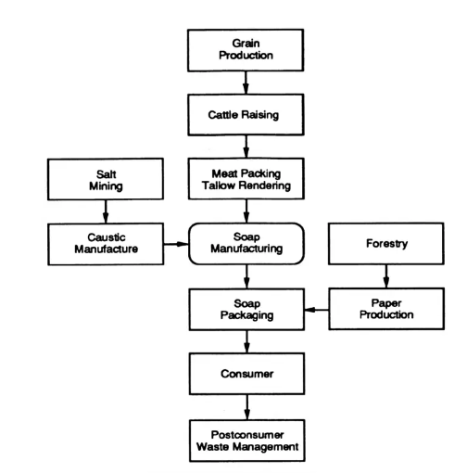

**Architecture diagram of soap production**